IMC Glass have invested in the design and manufacture of these specialist slim double glazed units that satisfy the requirements of a low sight line to be fitted in traditional timber frames and we are the ONLY fully certified manufacturer of heritage type double-glazed units in all of Ireland.
It is no longer necessary to expect people who live in old buildings not to optimise their insulation. This product provides the alternative to turning up the heating and allows people to live more comfortably in older properties. The Slim-glaze warm edge spacer technology consists of a poly metric tape that has a desiccant embedded in its structure. It is physically smaller than a contemporary spacer bar and more attractive. It allows the perimeter margin to be kept to a minimum so it can be glazed in traditional glazing rebates.





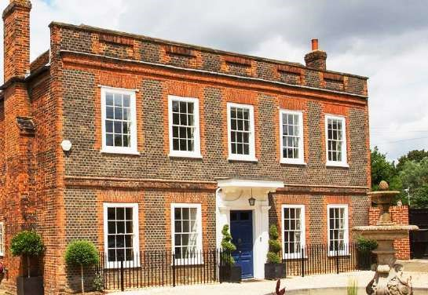
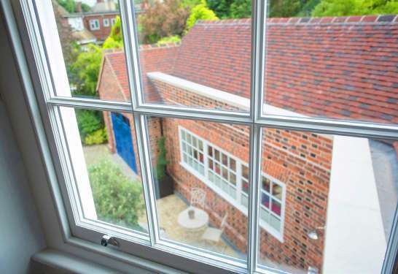
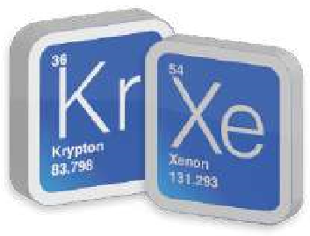
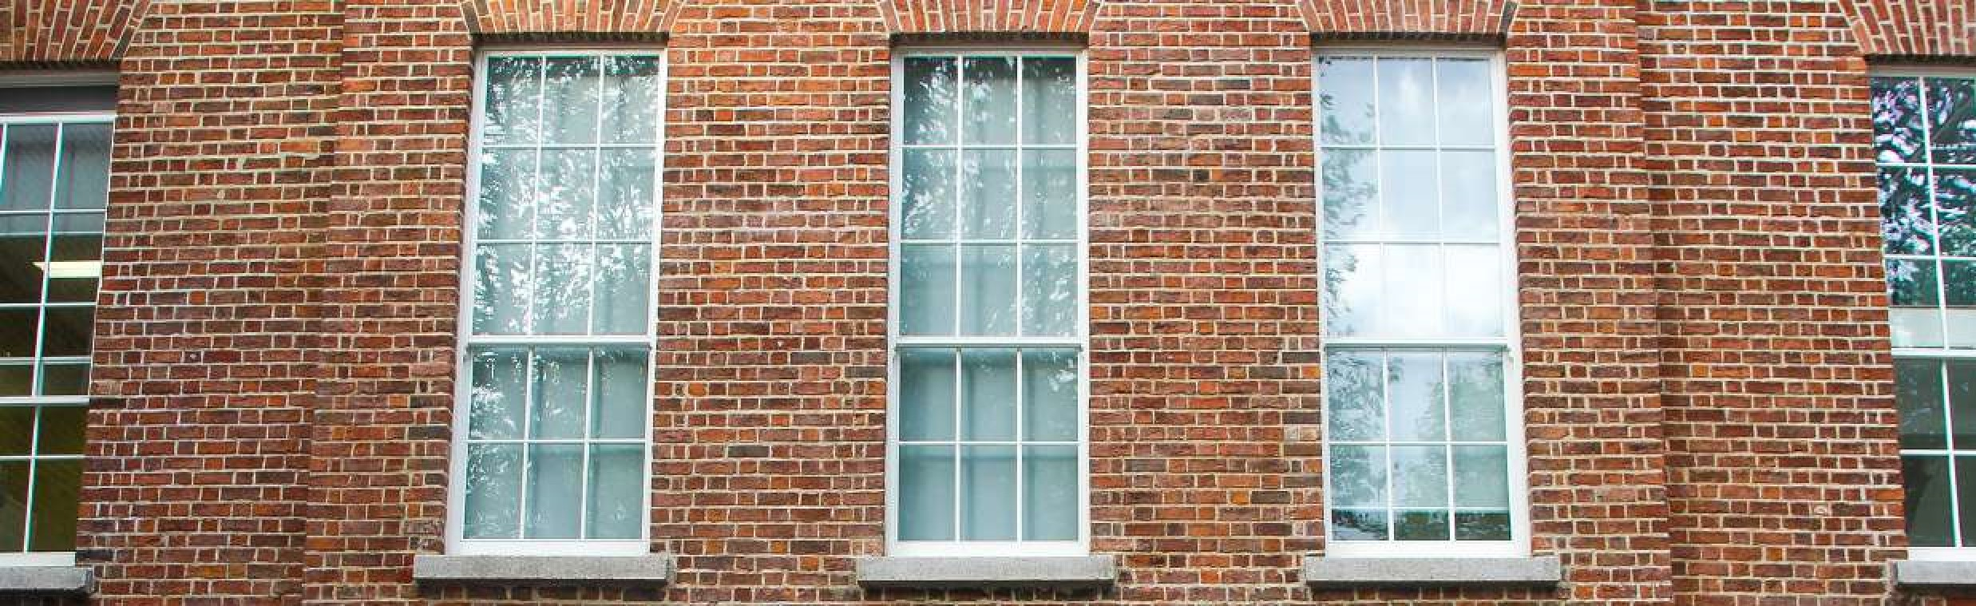


















The double glazing has a perimeter seal from edge of glass to inside of spacer bar of 7mm + or – 1mm. Units can also range from 11mm to 16mm in overall thickness. Large panes up to 1m2 only can be manufactured using 4mm spacer, for panes over 1m2 please increase the cavity to 6m or 8m depending upon the size of the unit required.
t:

028 3883 2123
e:
info@imcglass.com
www.imcglass.com
Award winner
for best exterior
product.
Architect
Choice Awards
Award Winners
BSEN 1279
NO: 68603
CE mark
Approved
OUR SLIM GLAZE
UNITS ARE FILLED
WITH PURE
KRYPTON OR XENON
GAS
Unlike other inferior products on the market, we only use pure krypton or xenon, not a krypton/argon mix, which is less efficient. We also use a sealant that has been specially designed for double glazing. It produces smaller, more discreet seals and is considered the best on the market.

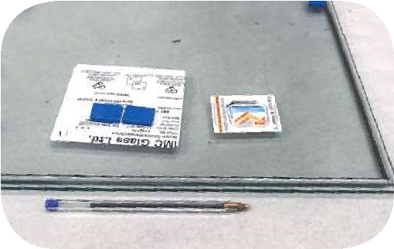
JUST HOW SLIM ARE OUR SLIM
GLAZE UNITS?
Our Slim Glaze units start at just 11mm overall thickness... about the diameter of a Biro.

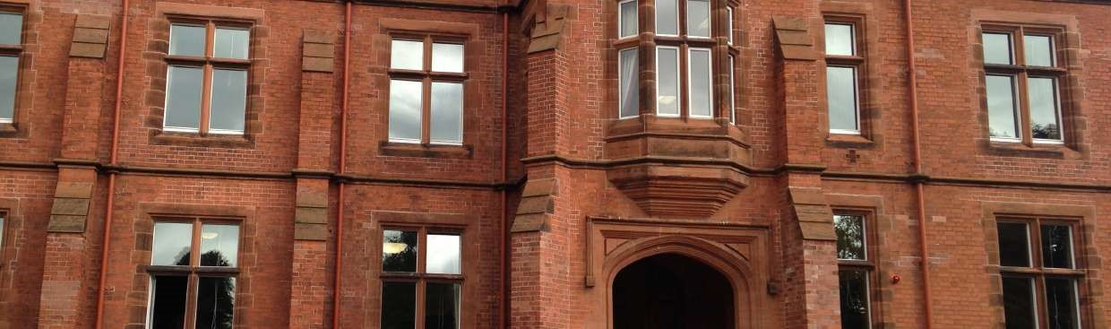



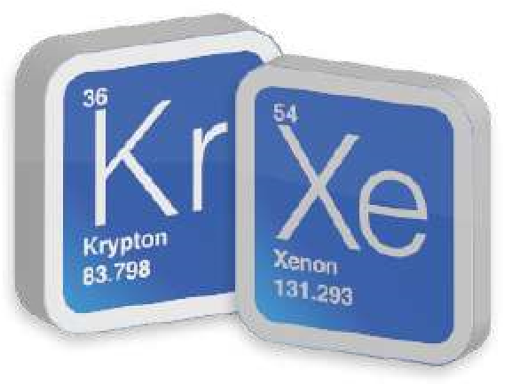



Ben ef it s o f Sl im G l a z e
D o u bl e G l a z in g
Thermal Efficiency
The thermal efficiency benefits of IMC Glass Slim Glaze double glazing can
now be even better than standard double glazing, achieving U-values (the term
used to measure thermal efficiency) of as low as 1.2 on a 6mm cavity and 1.1
on a 8-cavity, depending on the type of gas fill used in the cavity. The reduction
of heat lost through the glass is up to 77% as when compared against single
glazing and it is possible on some windows to use Slim- Glaze units to achieve
the Part L- building regulations for thermal efficiency.
Iner t Heav y Gas
The thermal conductivity properties of krypton and xenon are much lower
than air, meaning they are much more efficient insulators and are excellent at
reducing U-values in sealed double glazed units. All our slim glazing uses these
two gases exclusively, meaning you get excellent insulation against both cold
and noise.
Minimise Co nd ensat io n
Continual condensation can seriously deteriorate the lower sections of a timber
frames. Slim Glaze double glazed units will slow down the dew point being
reached. The inner pane of the double glazed unit is warmer than the outside
pane and our warm edge ‘super spacer’ bar acts as a thermal break, stopping
the cold reaching the inner pane of the unit. This helps maintain the room
temperature when the heating is switched off at night and thereby reduces
condensation and heat loss.
Al l Sl im Gl a z e d o u bl e g l a z ed u n it s
c a r r y a 5 y ea r w a r r a n t y a n d a c o py
c a n be s u ppl ied o n r eq u es t .
Pressure-sensitive
acrylic adhesive
Flexible silicone foam
Multi-layer
vapour barrier
Sl im Gl az e Spac er s
• High performance
•
Blend with any frame finish
• 4mm, 6mm or 8mm unit cavity
• Just 3mm in depth
• Ruler straight edges
• Sharp 90° corners

HOW IMC SLIM-GLAZE UNITS WORK

INVISIBLE COATING ON GLASS COMBINED WITH KRYPTON OR XENON GAS WORK THE SAME WAY A SILVER LINING WORKS IN A THERMOS BOTTLE
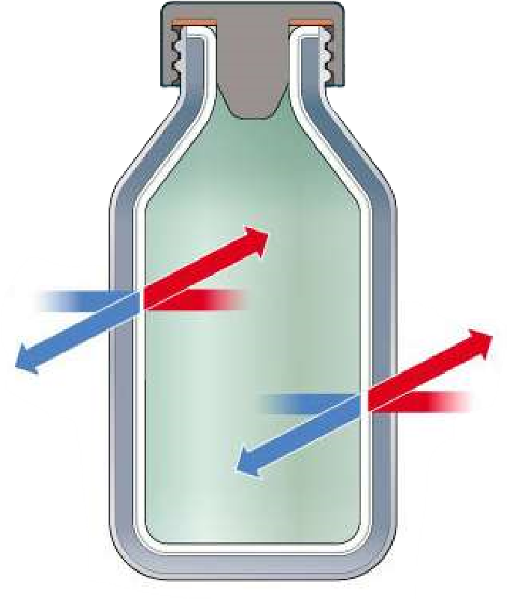
When a hot liquid is placed inside a silver lined thermos, the heat from that liquid tires to escape the thermos. The silver lining reflects the heat back inside, helping to maintain the liquid’s temperature.
With a cold liquid, the lining serves to repel the heat from the outside. The air space between the silver lining and the exterior of the thermos adds to the insulating value of the lining.
IMC Slim-Glaze coating work in the same way. These microscopically thin, invisible coating reflect the sun’s infrared light back outside to maintain comfortable temperature in the room and they increase the insulating value of the window.
With the cavity width inbetween the glass filled with Krypton or Xenon gas and using warm edge spacer which will slow down the dew point being reached and will act as a thermal break, stopping cold reaching inside.

STAY COOL IN SUMMER, WARM IN WINTER

IMC Slim-Glaze double glazing is designed to keep you cool in the summer and warm in the winter.
Many older double-glazed units do not contain lowemissivity (low-e) glass or inert gases like Krypton gas which means they are poor at retaining energy and leads to major heat loss within the home and therefore are not energy efficient.
IMC Slim-Glaze is designed to dramatically reduces the heat transfer and reflects exterior heat back into the home and keep cold out.

Summer Winter
Most visible

light passes IMC Slimglaze through
year round Keeps your home Keeps your home
interior cooler in interior warmer in warmer months cooler months

Special Coating Most harmful on glass surfaces UV rays are
Krypton or Xenon Gas reflected Inbetween glass panes outward
year round
Most summer

heat is
reflected In summer most In Winter
outside long wave solar most Radiant Very little
heat energy is heat from energy-savings blocked home is radiant heat

reflected escapes in inside the winter
NEED GREATER TRANSPARENCY?
When the sun shines through a window the room heats up Slim Glaze Super Clear incorporates the leading glass and this is referred to as Solar Factor or Gain, which will in this market, Pilkington Optiwhite. It has a high Light provide a measure of free winter heating. This extra Solar Transmission of 85% and therefore a high Solar Factor of benefit also increases the Window Energy Ratings. 79% which means cheaper heating bills in the winter.
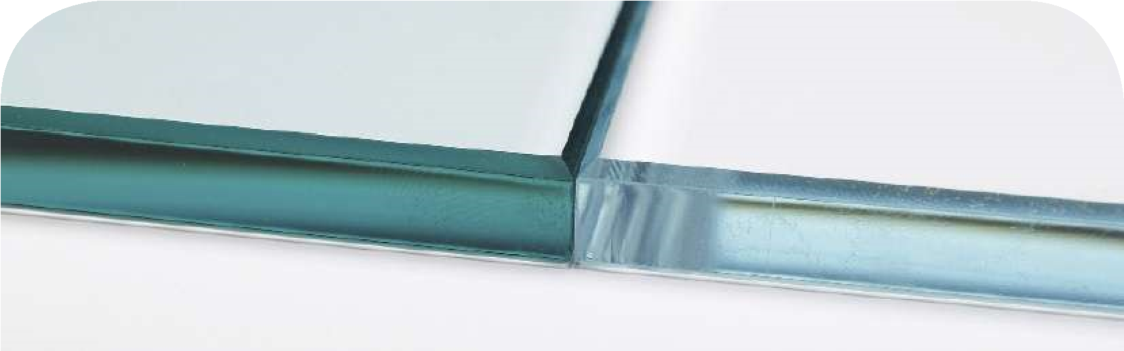
Pilkington Optifloat™ Clear
Pilkington Optiwhite™

Pilkington Optiwhite™ is a low-iron extra clear float glass with very high light transmission.
The highest noise insulation is
achieved using an acoustic laminated
glass. Glass controls noise by
•
reflecting
th noise back towards
the source, and
•
absorbing
the energy within the
glass
The sound meets
the glass obstacle
Sounds emitted
Sounds transmitted
Acoustic interlayer
Sounds re
fl
ected
The reason why Pilkington Optiwhite is such an excellent choice for Slim Glaze Super Clear is the sheer variety of solar factor benefits it can offer. It is practically colourless, and the green cast inherent to other glasses is not present. It is therefore ideal for use where glass edges are visible or where a neutral colour is desired. As its light transmission is higher than clear float glass, it is perfect for applications where high transparency is important. | Low-iron glass like Pilkington Optiwhite is made using carefully selected raw materials with a naturally low iron content. The melting process is tightly controlled to ensure that the product properties remain consistent, using along with a Low-E coated glass, Warm Edge and Krypton Gas can greatly enhance the Window Energy Rating.
NEED BETTER SOUND REDUC TION?
No matter where it originates, from railways, aircraft or factories, noise is all around. Future trend research suggests that traffic and noise in general will only get worse.
The careful and considered selection of glass can be crucial in helping to reduce noise level and meet noise requirements.
Pilkington Optiphon™ is a high quality acoustic laminated glass that offers excellent noise reduction without compromising on light transmittance or impact performance. The desired acoustic performance can be achieved through combining various thicknesses of glass with a special PVB
(polyvinylbutyral) interlayer. With a large variety of product combinations, Pilkington Optiphon™ offers the opportunity to achieve specific noise reduction requirements.
Pr o d uc t f eat ur es and benef it s:
- Provides a range of noise control levels
- A thin and lightweight solution to noise problems
- Achieves safety class 1(B)1 (EN 12600) and is available to meet security glass classifications in accordance with EN 356
- In case of breakage remains intact, minimising the risk of injury

SLIM GLAZE DGU SPECIFICATIONS
Overall Thickness | Glass Thickness | Internal Gas Space | Gas | U Value
11mm | 3mm | 4mm | Xenon | 1.4
11mm | 3mm | 4mm | Krypton | 1.9
12mm | 4mm | 4mm | Xenon | 1.4
12mm | 4mm | 4mm | Krypton | 1.9
14mm | 4mm | 6mm | Xenon | 1.2
14mm | 4mm | 6mm | Krypton | 1.5
16mm | 4mm | 8mm | Xenon | 1.1
16mm 4mm 8mm Krypton 1.3

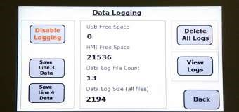
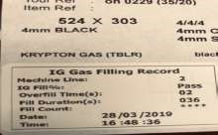

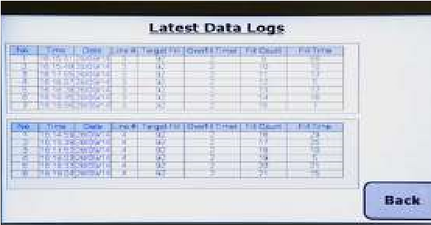
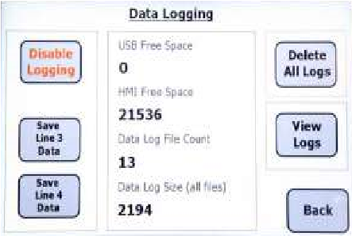
SLIM-GLAZE GAS FILLING
All slim-glaze units are gas filled using the Inagas advanced smartfill data log machine with this machine customers will have peace of mind and be assured that each and every unit manufactured by us will come with an unique label not only showing the time and date the unit was manufactured but also the gas filling percentage and fill cycle duration all information on the unit label can be used as an integral part of any quality control system as well as providing additional reassurance to any chain of command during project’s.

BEFORE AND AFTER ST COMGALLS SCHOOL, BELFAST
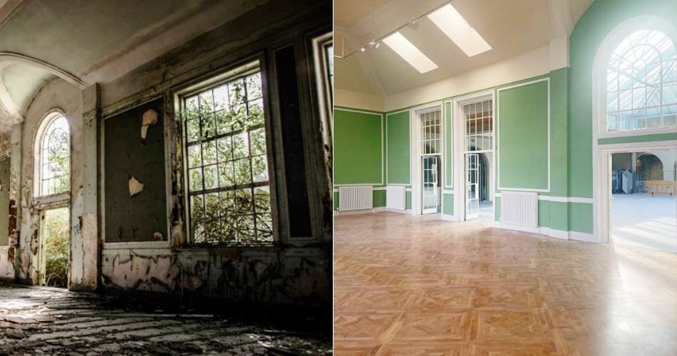
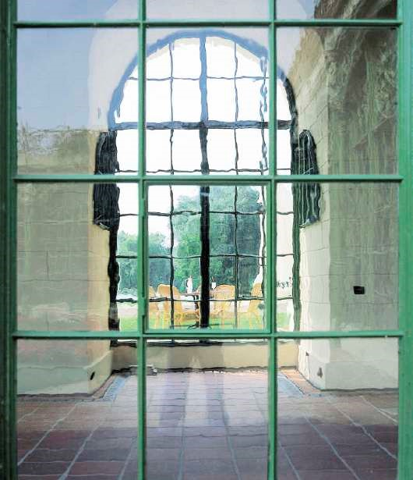
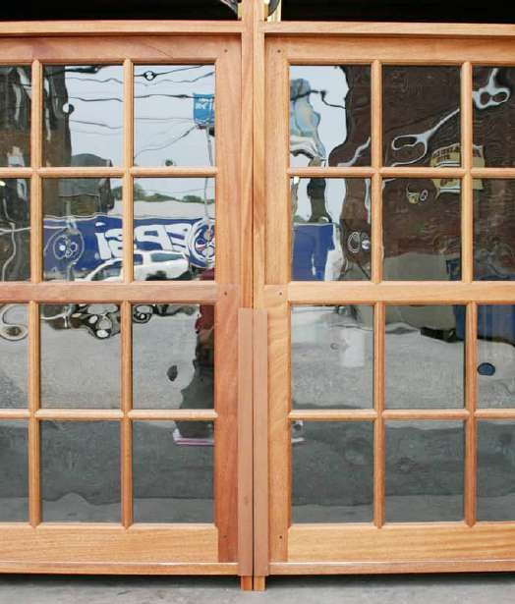


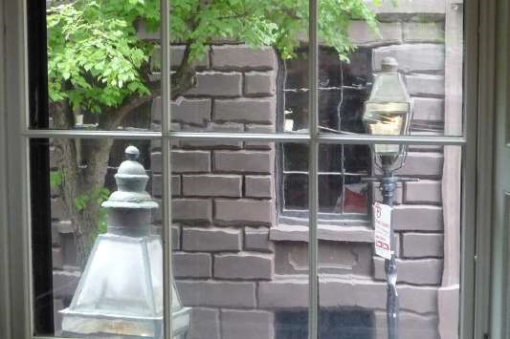
HISTORIC AL G L ASS
Cyl ind er Gl ass
It’s ideal for properties which have a Georgian and early
Victorian style. This type of glass is the most difficult
to date, as both drawn glass and crown glass (made by
blowing a spherical opening one end and spinning it flat)
were made alongside each other for a considerable time.
Cylinder glass dominated until the late 1700s, after which
it was pushed out of the market by drawn glass.
Drawn Glass
Drawn glass was first produced in the early 20th Century,
so it’s suitable for British period properties dating from
1915
to around 1950. Even beyond the Victorian era, the
age of a property determines the most authentic glass type
to use in replacement glazing. Drawn glass is made using
the Fourcault principle, developed in the early 1900s in
Belgium by Emile Fourcault. It uses a vertical ‘draw’, aided
by gravity, to form the glass.
The process involves glass being drawn directly from the
tank at the working end of the furnace. A boat-shaped
slotted block, made of refractory material, is pushed down
into the molten glass. As the hot extruded glass rises
through the slot, it is grasped by an iron bait.
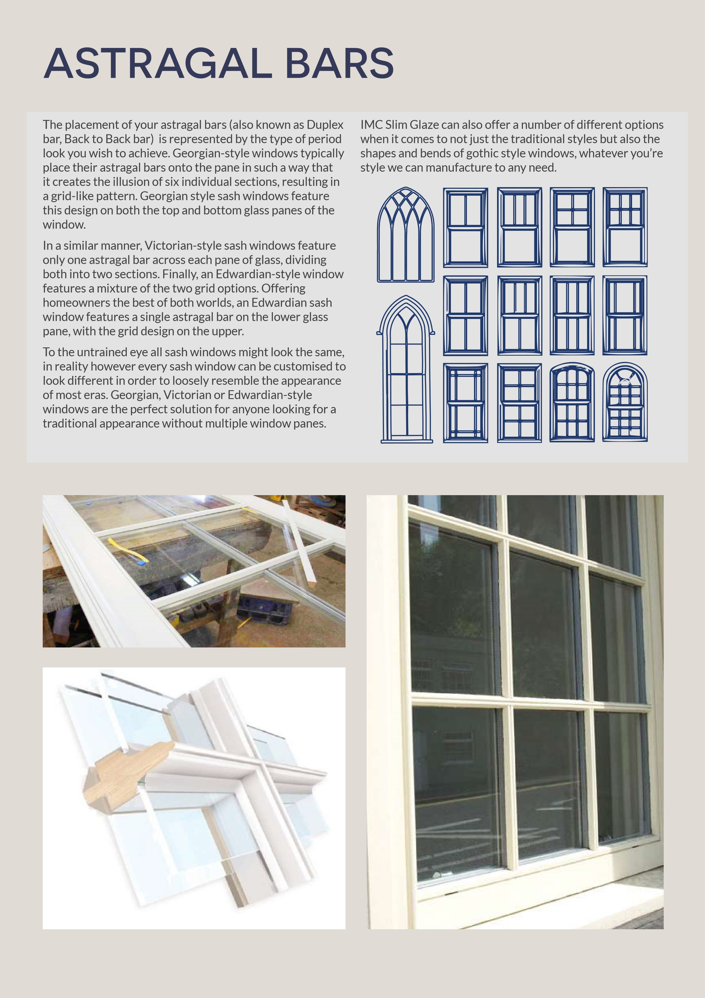
SOME PROJECTS THAT HAVE OUR SLIM-GLAZE RANGE INSTALLED
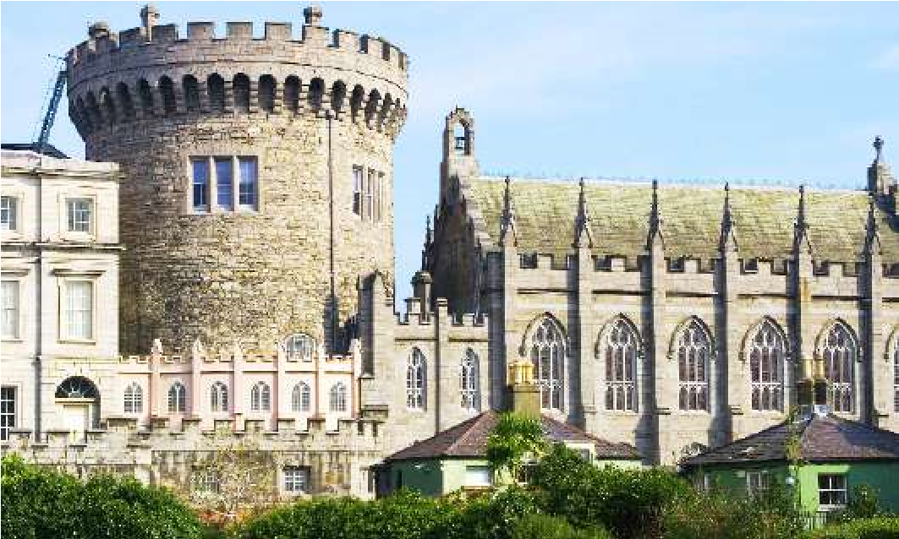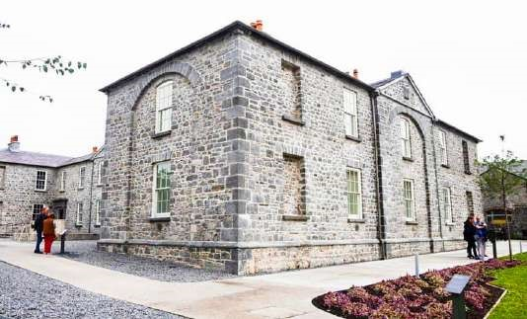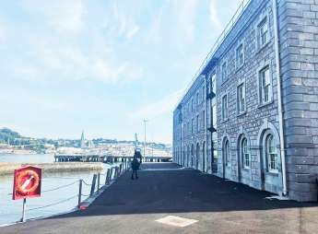
Farmham Estate, Co. Cavan
Dromoland Castle Co. Clare
Butler Gallery, Kilkenny
Adare Manor, Co. Limerick
Dublin Castle
Haulbowline Naval, Cork
Bank of Ireland, Dublin
Derry Craft Village

Cashel Palace, Tipperary
British Ambassador Residence, Dublin
Kildare Village Shopping Outlet
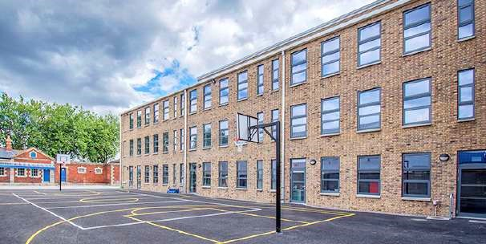
Griffith Barracks Multidenominational School, Dublin
Hillsborough Castle Grounds
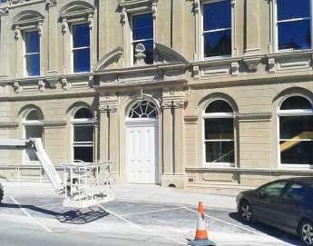
Department of Education, Dublin
Royal College of Surgeons, Dublin
Clayton Hotel, Dublin

Clongowes Wood College, Kildare
ESB Building, Dublin
Primark, Belfast

IMC Gl ass Cer t if ic at io n
IMC Glass work closely with BSI and have independent testing on our products carried out twice a year as per BSEN1279 part 6 Annex B Audit test.
Our quality management/production systems are also independently audited by the notified body (BSI) to ensure the on-going quality of our products.
These are the certificates we hold:
- Certificate BSEN1279 Part 2 BSI 262/4677672
(Production Quality)
- Certificate BSEN1279 Part 3 BSI 371/7758378 (Gas Leakage)
- Certificate BSEN1279 Part 6 SDG0703/11870B
Annex B Audit Test, Declaration Of Performance
Number 68603
- Certificate BSEN673 UKAS Certified U-Value
(Insulation)
Certification CE and BSEN1279 Approved
To manufacture double glazed units, certification is required for BSEN1279 Part 2, production quality and BSEN1279 Part 3, which relates to gas leakage at less than 1% per annum. Certification is your guarantee of quality and reliability.
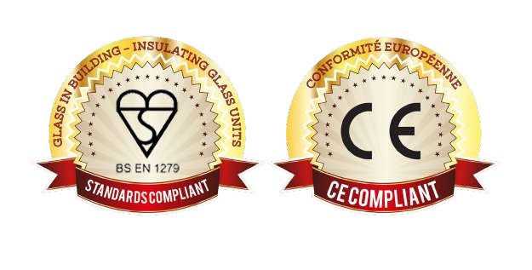
It is a legal requirement that all double glazed units must have CE mark in accordance with construction products Regulation declaration of performance.

Saf et y Gl ass Standar d s
Safety glass required for all door and sidelights and any glass in a window below 800mm from the floor and can be toughened or laminated glass. Laminate glass has less breaking resistance than toughened glass. Laminated glass will provide protection to internal furnishings as Ultra Violet radiation is reduced by 98/99% and a slightly better acoustic rating.
All Double Glazed Units can be constructed with any type of glass or thickness. The width of the cavities determine the insulation or U Value, the thickness of glass has no effect on U Values.
All simulations of U-values can be available on request.
Critical locations where safety glazing must be used
Locations where safety glazing is not required
mm
300
300
mm
800
mm
800
mm
1500
mm

Our Safety Glass Standards
- Toughened glass, Class 1 BSEN 12150
- Laminated glass, Class 2 BSEN 14449

GLAZING INSTALLATION RECOMMENDATIONS

Glazing Materials
- Hodgson Silfix U9 Low moisture Neutral-cure silicon which cures to form a flexible rubber.
- Hodgson flexistrip a security glazing strip for double-glazing units and laminated glass.
- Hodgson colour glaze putty
- Hodgson multi- purpose putty
- Hodgson butyl 66
Dry seal mp manufactured by repaircare a non-linseed based product manufactured by repair-care which is a durable alternative to putty.
Moisture Attack

Face-Pointed Frames
Slim Glaze units to be bedded in back rebate with approximately 2mm of butyl (non-hardening compound) or with flexistrip and centred in rebate with spacers or packers, (the latter not required if using flexistrip) to keep the unit raised from the rebate platform completely fill the void area with silfix silicone and allow to completely cure. The units can then be putty fronted using one of the above product’s making sure there is full adhesion to the frame and glass and no areas for water to enter the glazing system.

Beaded Frames
Treat in the same way as above up to the point of putty-fronting. Timber beads to be secured against glass using nails or screws and sealed with Silfix U9 low moisture Silicone to completely seal any residual voids between glass and rebate and glass and bead. Finish with paint application making contact with glass both inside and outside. It is very important that regular maintenance of the frames and glazing system is undertaken to prevent the access of water into the glazing system.

The major enemy of insulated glass units is water. If water is trapped in contact with the seal of the unit for a period of time, the unit will fail. All glazing systems must protect the edge of the insulated glass unit, either by preventing access of water or by proper drainage and ventilation.

Warning
SOME SILICONES ARE NOT SUITABLE FOR USE WITH SEALED UNITS. A SILICONE COMPONENT (PLASTICIZER) CAN MIGRATE TO THE PRIMARY SEAL CAUSING CATASTROPHIC FAILURE OF THE UNIT, IF IN DOUBT PLEASE CONTACT YOUR SUPPLIER BEFORE INSTALLING.
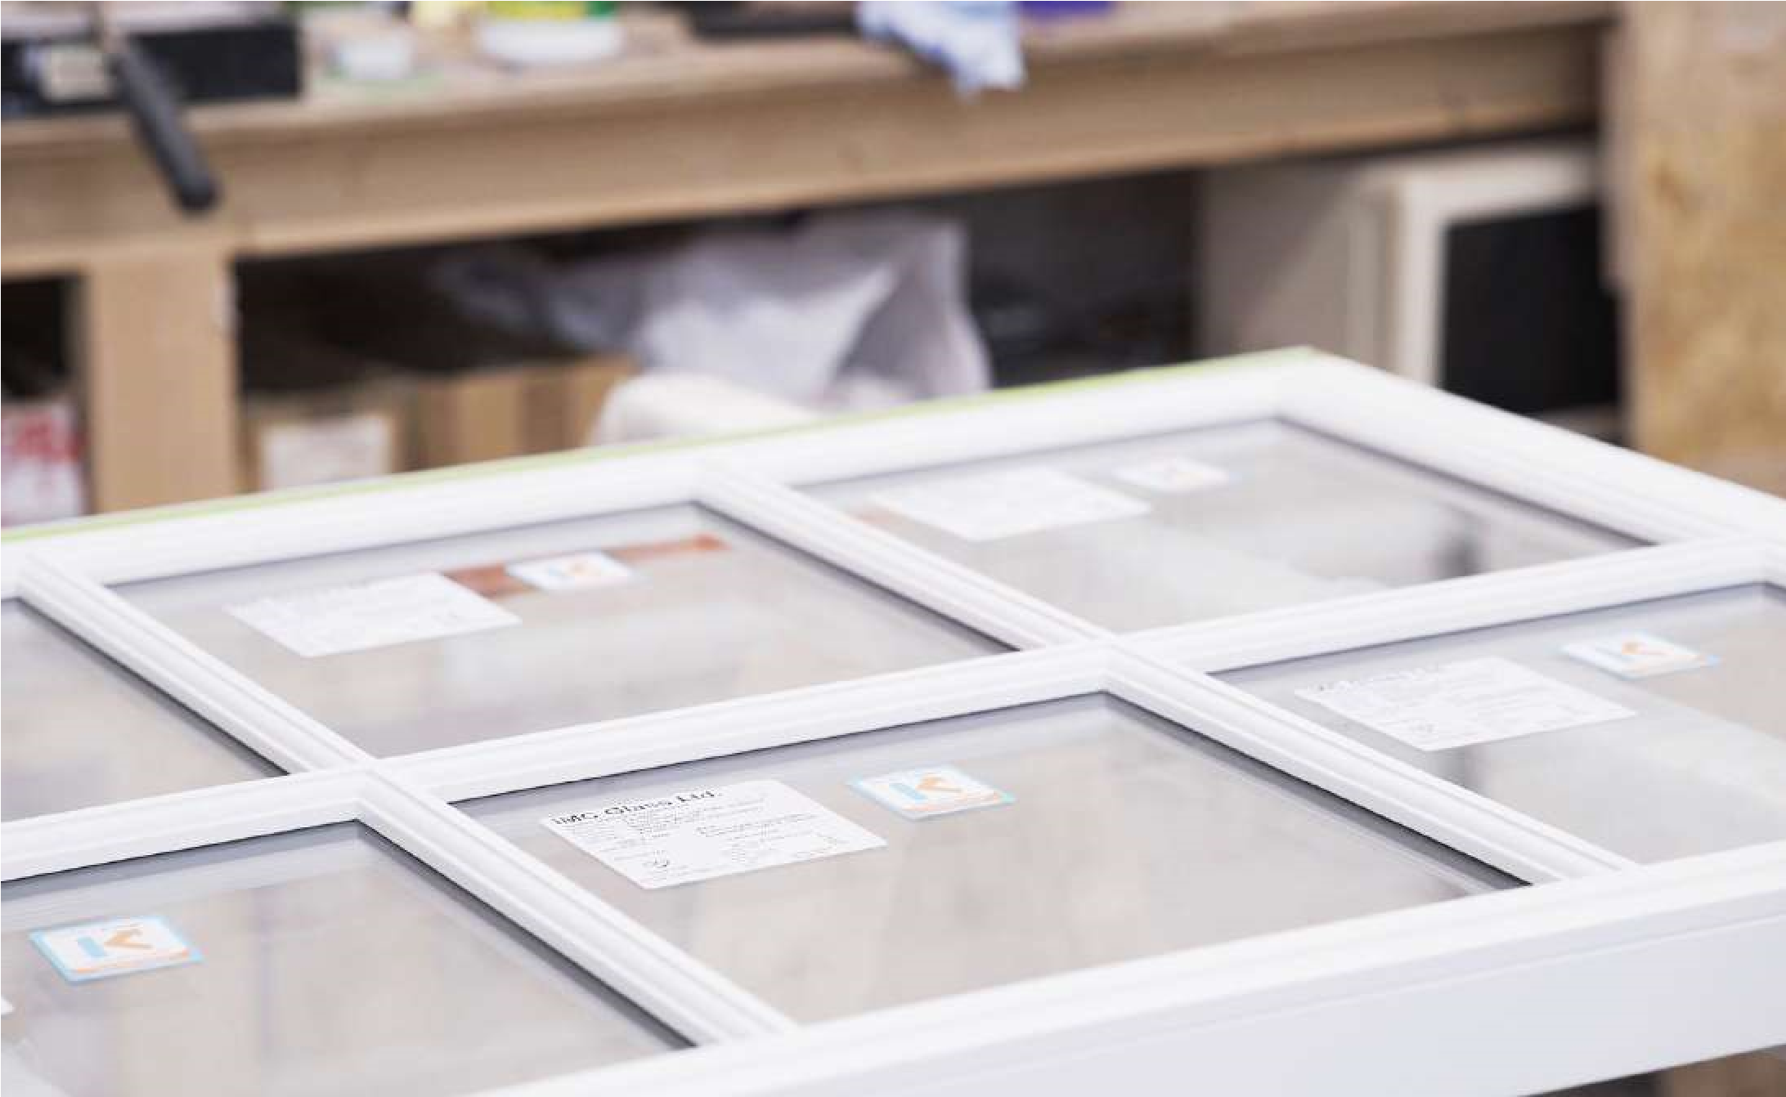

GLAZING MAINTENANCE RECOMMENDATIONS

To obtain maximum life expectancy for sealed units, it is essential that water is prevented from leaking round the glazing putty / gasket into the frame and lodging there. Glazing and maintenance recommendations must therefore be carried out in accordance with the unit maker’s instructions. The schedules of maintenance detailed below refer to commonly used and accepted glazing systems are approved by the Glass and Glazing Federation for houses and low rise buildings. Where other systems have been used the unit maker should be consulted for advice on maintenance. Glazing should be inspected at least annually and treated as necessary.
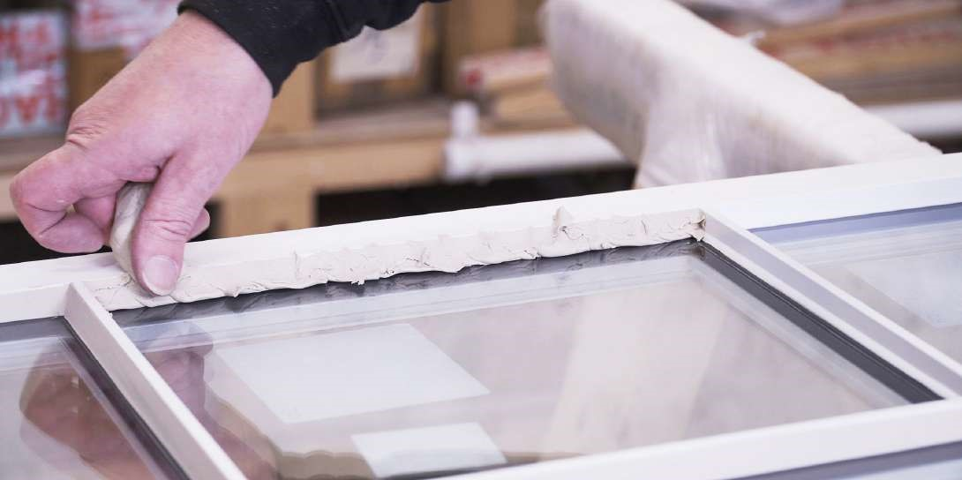
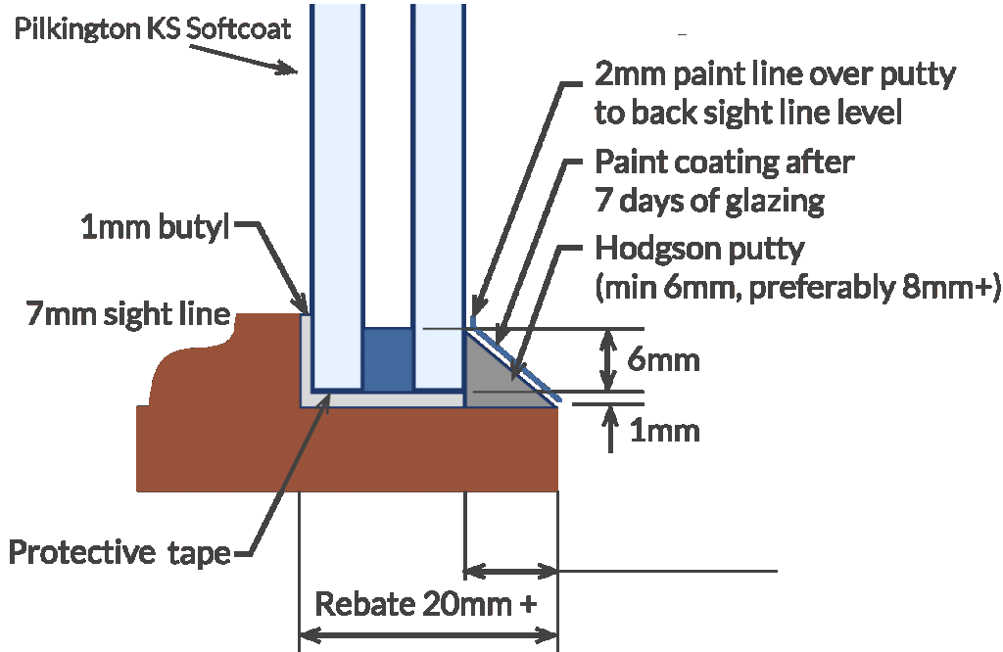
Standard units fitted into wooden frames with beads, using non-setting glazing compound and silicone sealant: Where they are surface cracks, loss of adhesion or voids, rake or remove the faulty compound or sealant and replace with non-setting compound or silicone sealant, preferably the same as originally used. Always use non-setting glazing compound for back bedding repair purposes. When pointing non-setting glazing compound between the beads and glass ensure that, the compound slopes away from the glass. When using silicone sealant ensure that the sealant is proud of the glass, this will prevent water lodgement occurring.
Standard units fitted into frames with beads, using gaskets or mastic load bearing strips: this system is normally used for glazing into aluminium and uPVC window and door frames. Check annually for obvious deterioration and ensure that all drainage holes are free from obstruction.
IF A SERIOUS FAULT DEVELOPS INFORM YOUR
SUPPLIER AT ONCE

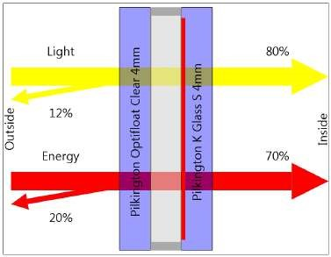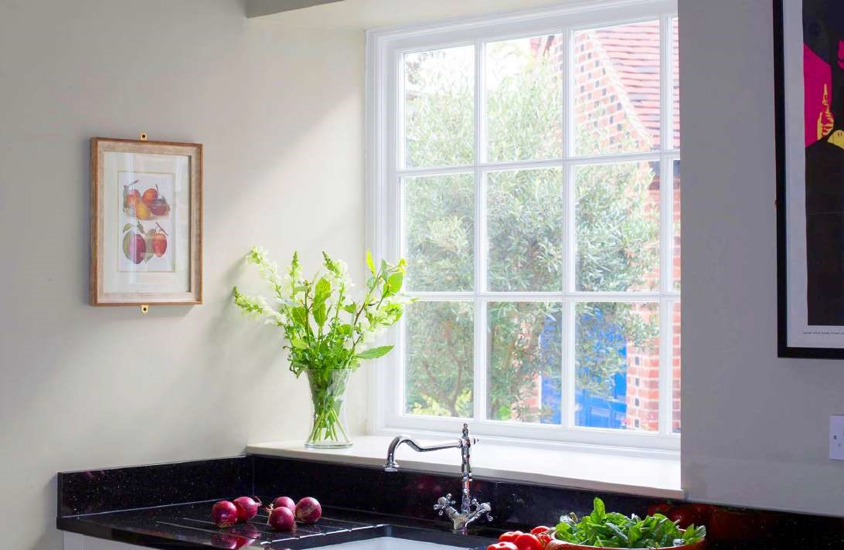
IMC Glass can always provide data sheets which can be calculated for a
wide range of products to determine their key properties such as light
transmittance, solar gain and U-value
Many product combinations can be available on request and can be
provided for customers to forward on architects/planning officers etc
to ensure that you are provided with all the necessary information for
project specific requirements.
DATA SHEET FOR STANDARD

4
/4/4 SLIM-GLAZE
Product Code | U Value | UV % |  | Light % |  |  | Energy % |  | Solar Factor | Shading Coeff.
4-4Kr-KS4 | W/m²K | Tuv | LT | LR out | LR in | ET | ER | EA | g | T SC | S SC
4-4Kr-KS4 | 1.9 | 39 | 80 | 12 | 12 | 61 | 20 | 20 | 0.70 | 0.80 | 0.70
Performance Code | Sound Reduction | Ra | Thickness | Weight kg/m² | Selectivity
U-Value/Light/Energy | Rw dB | 98 | mm | Rw dB (C;Ctr) | 1.14
1.9 / 80 / 70 | 29 | 98 | 12 | 20.00 | 1.14
Glass 1
Pilkington Optifloat Clear 4mm
Glass 2
Pilkington K Glass S 4mm
We Del iv er Ac r o s s Ir el a n d & t h e UK

We currently have deliveries in Dublin and Northern Ireland on a regular basis but can accommodate anywhere in the UK and Ireland using our connections in the courier trade, all large orders will come packed securely on a wooden A-frame and delivered straight to your preferred destination



GENERAL INFORMATION
ON HEAT LOSS

TIMBER WINDOWS
SOME INFORMATION ON
HEAT LOSS IN GLAZED
TIMBER SASH & CASE
WINDOWS
Single glazed timber sash and case
windows are extremely poor at retaining
energy. The heat loss through single glazing
which has a U-Value of 5.4 is around 77%.
Usually the single pane of glass will be at
approximately the same temperature as it
is outside. In colder conditions in a room at
around 20 degrees centigrade, the warm
air will contact the cold single glazing and
drop downwards at a rate exceeding two
metres per second, sometimes mistakenly
considered as a draught through window
construction joints.
This causes a constant convection in a
room where the air is being heated and
then cooled by the cold single glazing,
resulting in an expensive, continual heat
loss, through the glass.
Low E Double Glazing such as Slim-Glaze
will reduce heating energy costs by at
least 20%, due in part to the Low E glass
which reflects the long wave radiation or
heat back into the room, combined with
the insulating inert gases contained in the
cavity of Slim-Glaze, Krypton and Xenon
are the most effective inert gas insulators
as the thermal conductivity properties
are much lower than air, meaning they are
excellent at reducing U-values in sealed
double glazed units
The insulating effect keeps the inside pane,
normally the Low E glass much warmer
than the outside temperature, thereby
considerably slowing down the convection
mentioned above and reducing heat loss by
around 50%.
Recent figures estimate that replacement
of one square meter of single glazing for
Low E double glazing will provide a saving
of approximately 90Kg of carbon dioxide
emissions per year. Reducing your carbon
footprint

THE DANGERS OF USING UNCERTIFIED UNITS

Before you buy from any company please ensure that they can show you their EN1279 test results based on heritage units, if not then you could be using uncertified products and will not conform to any regulations set out by architects and planning officers .  So far IMC Glass is the only manufacturer in all of Ireland that has passed all test requirements , we spend many thousands each year to maintain our kite-mark which includes testing samples to B.S.I every | Please see link for recommendations when placing orders for narrow cavity units set out by the BWF.  https://www.bwf.org.uk/wp-content/ uploads/bwf-igu-advice.pdf  Also featured is an article written by BWF warning their members about this issue with strong warnings not to use any products made without certification.
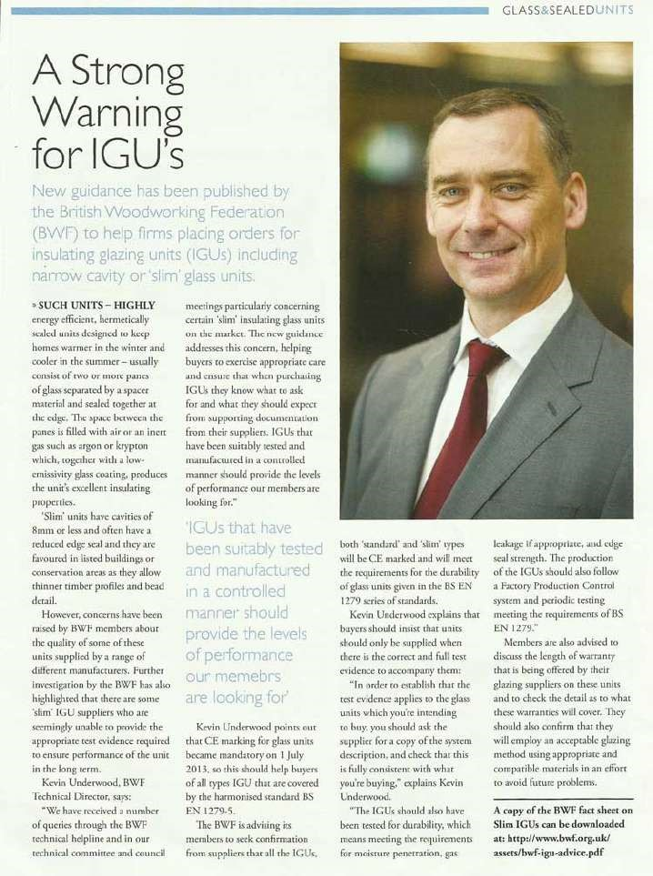
There are widespread concerns in the Industry in relation to some lessor known companies in Ireland now manufacturing their own version of our Slim-Glaze units, reduced sightline insulating glass units. (IGU’s) apart from these companies not having much or any experience within IGU manufacturing they are also using standard Argon gas to pass them off and in turn they will have more than 30% less energy efficiency. Why take a chance on a product which already underperforms, hasn’t been tested and could lead to more issues down the line? even one these companies based around Rathmines area of Dublin have even resorted to copying and pasting from our own website in an effort to try and make themselves look genuine.
6
months .
All IGUs placed on the European
Market and UK must, under the Construction Products Regulations, be manufactured in accordance with all parts (1 to 6) of EN 1279, the harmonised European Standard for Insulating Glass Units.
The primary requirements of EN 1279 to demonstrate durability of the IGU, to provide a reasonable service life are:
- Testing to EN 1279 part 2 – Long term test method and requirements for moisture penetration to ensure they don’t “condensate inside cavity space”.
- Testing to EN 1279 part 3 – Long term test method and requirement for gas leakage rate and for gas concentration tolerances to guarantee that gas cannot escape the unit .
There also needs to be a clear system description to prove that the test evidence, that some companies are producing, relate specifically to the low sightline narrow cavity units (heritage) and not to standard units. which are two totally different test requirements as some places have been trying to “bluff” their way showing test results based on standard units.


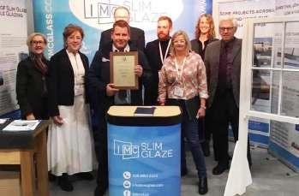
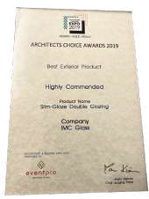

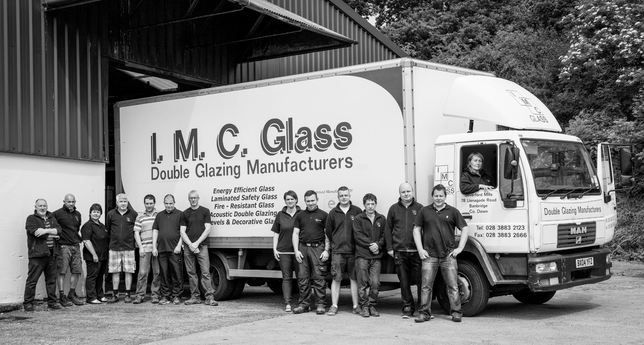

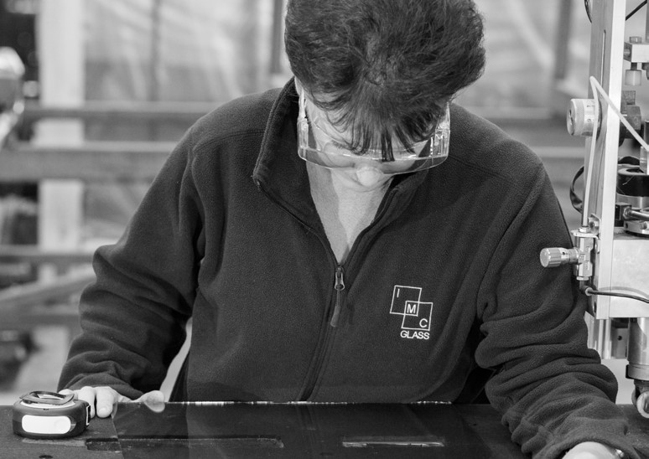
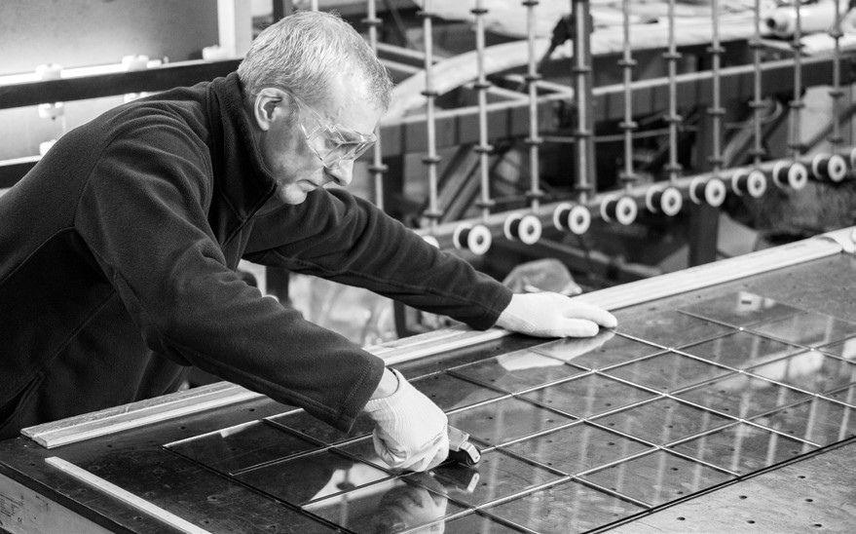
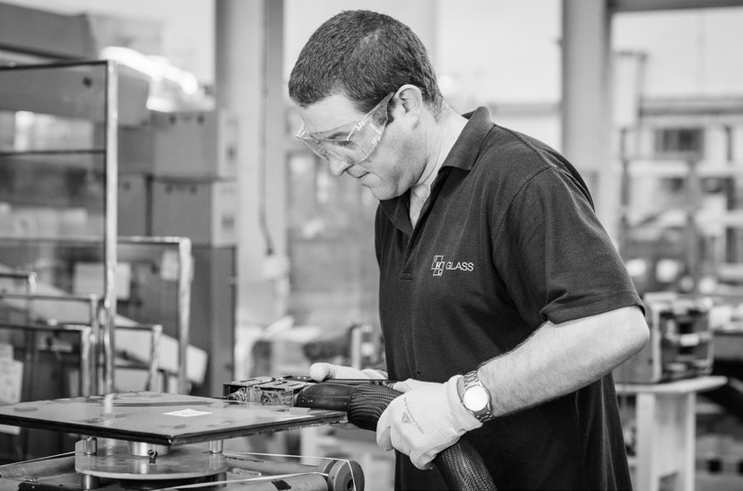
The Slim-Glaze range is produced by IMC Glass, a family run company founded in 1990 that has been manufacturing double glazing for nearly 35 years and are B.S.I. Kite marked to the latest European standards.
FEEL FREE TO CALL OUR OFFICE ON
(028) 3883 2123
TO TALK
TO A MEMBER OF OUR TEAM, OR EMAIL
INFO@IMCGLASS.COM
AWARD WINNER AT THE ARCHITECT
CHOICE AWARDS FOR BEST
EXTERIOR PRODUCT.
Voted by The Royal
Institute of Architects
of Ireland
www.imcglass.com
ABOUT IMC GLASS
We are also a Pilkington glass energiKare™ partner, offering the latest in energy saving glasses.
We are based just 2 minutes off the A1 dual carriageway beside Loughbrickland.

